Environmental Micrometeorology
(Class #: 2938)

Final exam (Closed Books and Notes)

Hour: 2 (3:00 ~ 5:00 pm)
Date: 18 December 2001

Student Name: _______________
Student’s SIGNATURE: _____________
Student I.D. Number: _____________

Directions: Please enter your name on this page. Then sign the examination and enter your student identification number above. Time allowed for this examination is 2 hours. Answer all questions on a separate paper provided. Be precise, logical, and ordered in your responses. Show all your work! I cannot do give any credit if you do not write anything.

(20 pt) 1. Answer the following questions.

- Give the definition of atmospheric pressure.

- What is the potential temperature?

- List main forces effecting the horizontal motion of air.

- What is the difference(s) between mechanical and thermal contacts?

- What is the sensible heat flux?

(20 pt) 2. Answer the following each item.

  - Explain why the air pressure at high levels, for example, mountain tops, is lower than that at sea one.

  - For an extensive, flat and homogeneous ideal surface, identify the various components that define the energy balance. For each component, explain the principal environmental conditions controlling the magnitude of the energy flows.

(10 pt) 3. On December 15, 2001 at a high altitude over the Korean Peninsula, the pressure topography at 16:10 pm could appear as shown below. The surface pressure is 1,000 hPa (1 mbar = 1 hPa) at which the temperature is assumed to be 0ºC.

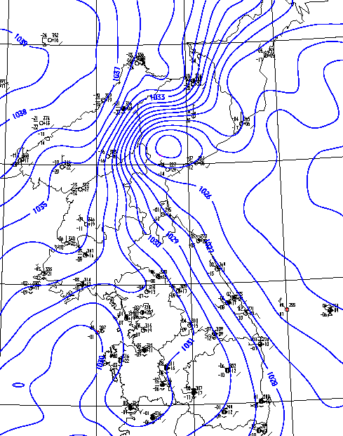

L

H

L

- If one considers the distribution of atmospheric pressure indicated by a box, where may the horizontal dispersion of air pollutants be directed to?

- Calculate each elevation corresponding to the isobaric lines indicated by a circle. In doing this, use a 4-hPa interval between the isobars from 1026 to 1034 hPa.

(Hint: $z=z_{o}−\frac{\text{RT}}{{\text{gM}}_{a}}\text{ln}\frac{P}{P_{o}}$ [m], where R is the gas constant, g is the gravity acceleration, and M_{a} is the molecular weight of air.)

(c) Draw the results obtained from the calculation above.

(30 pt) 4. Let us consider a parcel of air present at a high altitude with no significant mixing with its surrounding air. The air would be behaved as an ideal gas dried adiabatically.

- Express the potential temperature (θ) at P_{o} = 1,000 mbar as a function of temperature (T) and pressure (P) at a chosen elevation. (Hint: Start with dQ = C_{p}dT – VdP, where C_{p} is the heat capacity of air at a constant pressure.)

(Ans) $θ=T{\left(\frac{P_{o}}{P}\right)}^{\frac{R}{C_{p}}}$
- Show that the potential temperature gradient of the air can appear to be:

$\left(\frac{dθ}{\text{dz}}\right)={\left(\frac{\text{dT}}{\text{dz}}\right)}_{\text{Environmental}}−{\left(\frac{\text{dT}}{\text{dz}}\right)}_{\text{Adiabatic}}$

(c) Estimate the dispersive behavior of air pollutants in the air when $\left(\frac{dθ}{\text{dz}}\right)$ has a negative value.

(20 pt) 5. On a clear August day (13:00 to 14:00 pm) at our University, the total incoming solar irradiance (K_{T}) measured over a grass field is 1,000 W/m². The net radiation (R_{N}) is 60% of K_{T,} and the soil heat flux is 10% of R_{N}. A 0.5-mm evapotranspiration occurred while the K_{T} measurements were obtained. Use the following constants: air density (ρ_{a}) = 1.225 kg/m³, heat capacity (C_{p}) = 1,004 J/kg·K, solar constant = 1,370 W/m², and latent heat of water vaporization = 2,500 J/g. (1 W = 1 J/s)

- Estimate the latent heat flux (H_{L}).

- Calculate the amount of energy available to heat the air.

- Find the Bowen ratio

Good luck on all your works to answer the questions.

Environmental Micrometeorology
(Class #: 3579)

Mid-exam.

Hour: ~ 2 (10:00 ~ 11:50 am)
Date: 17 June 2014

Student Name: _______________
Student’s SIGNATURE: ______________
Student I.D. Number: _____________

Directions: Please enter your name on this page. Then sign the examination and enter your student identification number above. Time allowed for this examination is ~ 2 hours. Answer all questions on a separate paper provided. Be precise, logical, and ordered in your responses. Show all your works! I can not do give any credit if you do not write anything.

(40 pt) 1. 다음 각 물음에 대하여 간략히 설명하시오.

- 복사역전(radiation inversion) (반드시 50자 이내로 기술)

- 대기혼합고(air mixing depth) (반드시 50자 이내로 기술)

- 압력을 나타내는 단위들의 예 (5개 이상 제시)

- 잠재온도(potential temperature) (반드시 50자 이내로 기술)

(20 pt) 2. 다음 각 물음에 대하여 간략히 설명하시오.

- 지표면으로부터 450 m 내에 존재하는 대기의 온도변화를 측정한 결과, 200 m미만에서의 온도(T₁)와 그 이상에서의 온도(T₂)가 서로 달랐는데, 이러한 대기 물리특성을 갖는 대기의 압력을 계산할 수 있는 식을 유도하시오. 이때, 200 m까지의 고도를 h₁, 200 ~ 450 m까지의 고도를 h₂라고 한다.

- 고기압의 대기 내로 배출된 대기오염물질들이 저기압 쪽으로 유동할 때, 일직선으로 이동하지 않고 시계 방향 또는 반시계 방향으로 휘어지는 이유를 설명하시오.

(20 pt) 3. 어느 한 지역의 풍속과 풍향 데이터를 기반으로 아래에 주어진 그림과 같은 바람장미(windrose)를 얻을 수 있었다. 다음 물음에 답하시오.

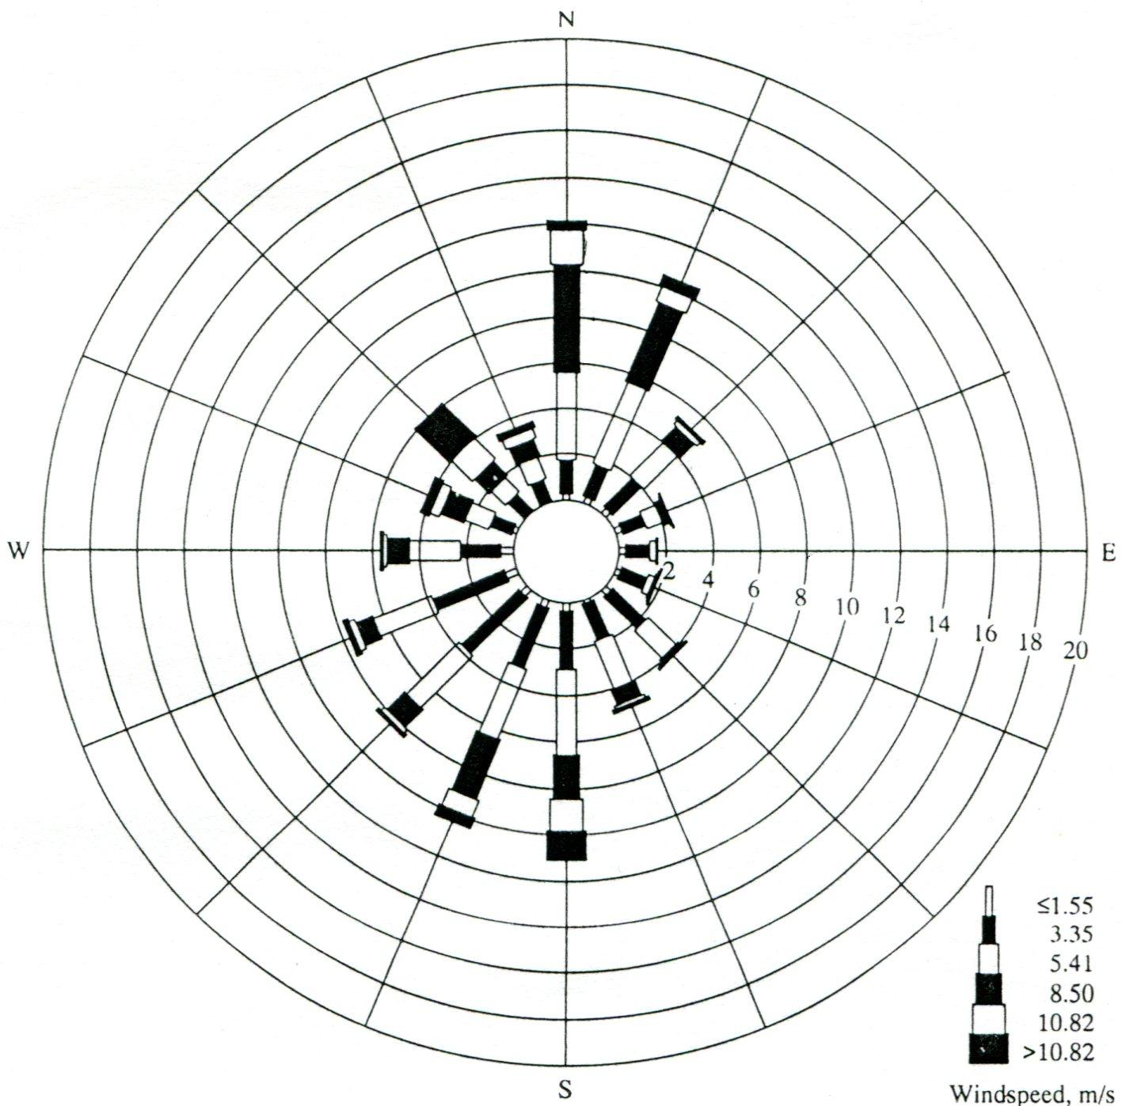

- 위의 바람장미를 얻기 위한 과정을 간략히 설명하고 이를 표(table)로 작성하여 보이시오.

- 위의 그림에서 알 수 있는 주풍(prevailing wind)을 기재하고 그 이유를 약술하시오 (반드시 50자 이내로 기술)

(20 pt) 4. 아래의 그림과 같은 연돌 연기배출 형태를 보고 그 연돌 주변 대기의 미기상학적 대기안정성을 유추할 수 있는데, 다음 물음에 간략히 답하시오

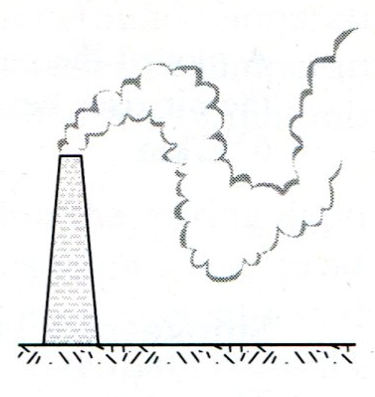

- 위의 연기배출모형을 설명할 수 있는 감률선을 그리고, 연돌 주변 대기의 안정성을 평가하시오.

- 연돌로부터 배출되는 연기의 배출이 일정주기를 가지고 상하로 유동하는 이유를 설명하시오. (반드시 100자 이내로 기술)

Good luck on all your works to answer the questions.

